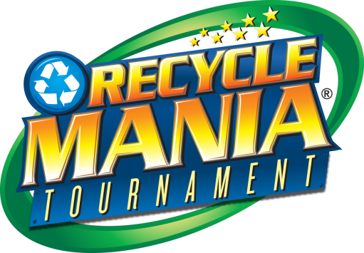
News Release

Seattle University Facilities

Release Date: April 9th, 2018 | Contact: Eric Elliott | Work: (206) 296-6459
Internet: www.seattleu.edu/recyclemania | Email: elliotte@seattleu.edu

Seattle University Comes in 6th Nationwide

Seattle, WA –Seattle University competed in the 2018 Recyclemania Competition for the second year this Spring and took 6th place in the waste diversion category out of 170 schools across North America. The 8-week competition allows Colleges and Universities to closely track and compare their recycling and composting rates against each other. Seattle University held 4th place for the first half of the competition, but fell to 6th place in the final weeks with a final diversion rate (recycling plus composting) of 74.8%. This is a huge improvement over last year’s first-ever performance of 12th place, with a diversion rate of 67.5%, and shows considerable improvement toward Seattle University’s goal of 80% diversion by 2020.

Seattle University Facilities has undertaken a number of changes to improve the University’s recycling and composting efforts, including updated signage, new bins and dumpsters. However, increased participation in Recyclemania events also contributed to the strong showing. This year, 14 student, staff, and faculty volunteers showed up to hand-sort over 1000lbs of the campus’ compostable waste at Garbology Episode III, and more than 60 individuals came by to bring their recyclables and contribute to the University’s diversion efforts at SU’s 9th Annual Community Recycling Day, about 20% more than last year! The university also collected about 3,000lbs of electronics for recycling over the 8-week period, which is almost 50% more than last year.

5th place was taken by Pacific Lutheran University in Tacoma, and Loyola Marymount University in Los Angeles took 2nd place nationwide for the 2nd year in a row with a diversion rate of 86.7%. These peer institutions show that there are still improvements to be made within the university’s recycling efforts, including collection of paper towels from campus bathrooms as compost instead of trash, and that with increased awareness and participation from the campus community, Seattle University can surpass our goal of 80% diversion well before 2020.

---

For more information about Recyclemania, please contact Eric Elliott at elliotte@seattleu.edu or check out www.seattleu.edu/recyclemania
Recyclemania in Numbers & Pictures

Garbology Episode III: Revenge of the Compost
- 14 volunteers over 6 hours, sorting 1000lbs of waste
- Out of 764 lbs of “compost” from our compost bins in dorms and public spaces:
  - Only 55 lbs of trash or recyclable contaminants, for an overall contamination rate of only about 7%
- About 60 tons of waste, or about 1 million lbs, of waste from Seattle University is composted every year!
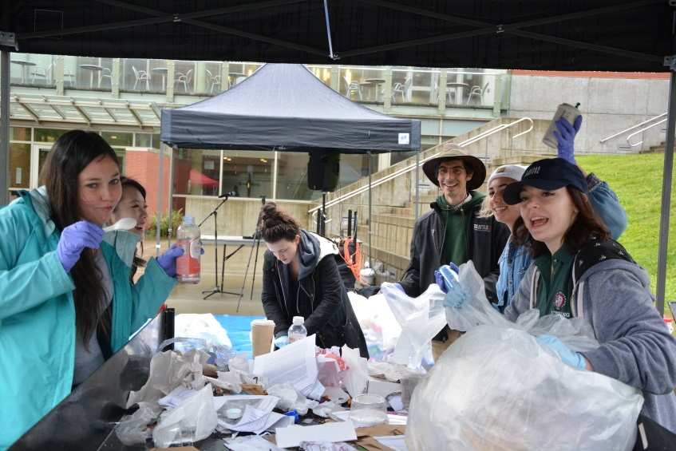
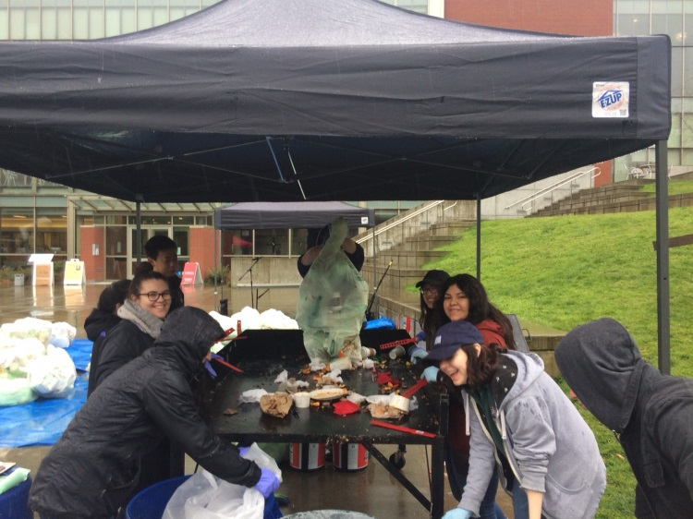

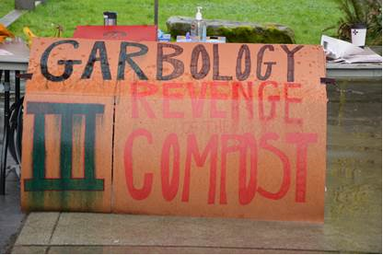
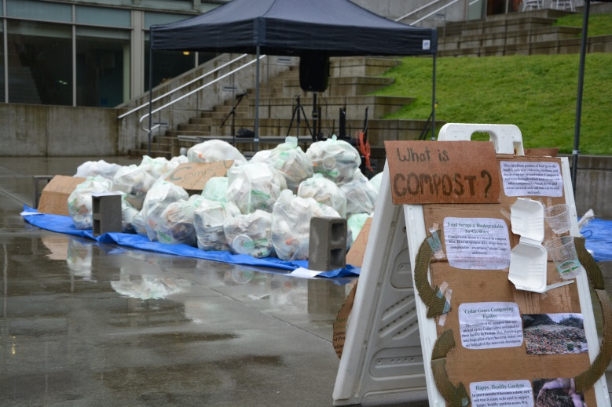

9th Annual Community Recycling Day
- More than 60 individual visits from SU and first-hill community members, about 20% more than last year!
- We collected about 880 lbs of scrap metal and over 6 cubic yards of Styrofoam, all of which will be recycled.
- We collected about 3,000 lbs of electronics for recycling. Almost 50% more than last year!

Final Recyclemania Scoreboard:
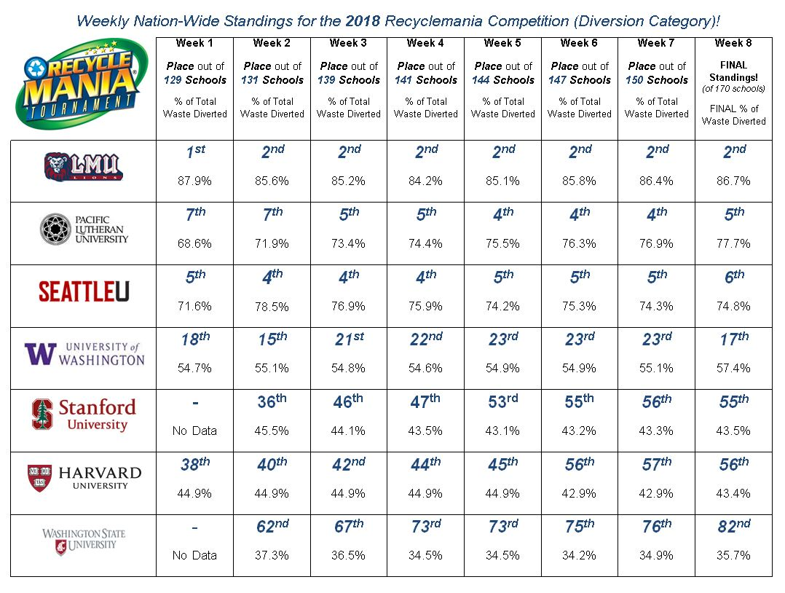
- 6th place with a final diversion rate (recycling plus composting) of 74.8%
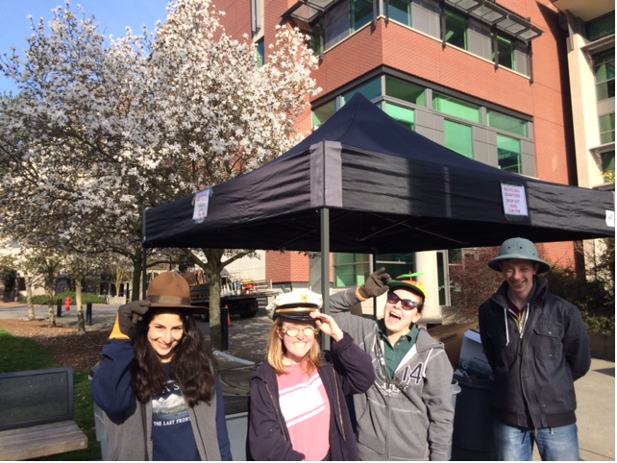
  - Compare to last year’s first-ever performance of 12th place, with a final diversion rate of 67.5%

