INSTRUCTIONS
The Death Penalty in the Age of Data, Science, and Abolition
May 22, 2020, 9:00-5:00pm - Online Continuing Education via Zoom Videoconference

WELCOME
We look forward to you joining the Seattle University Department of Criminal Justice Crime & Justice Research Center for our annual continuing education event - The Death Penalty in the Age of Data, Science, and Abolition. The event features keynote speakers Sister Helen Prejean, author of Dead Man Walking and River of Fire; Kirk Bloodsworth, Executive Director of Witness to Innocence and subject of the book Bloodsworth: The True Story of the First Death Row Inmate Exonerated by DNA Evidence; Dan Satterberg, King County Prosecuting Attorney; and speakers from Seattle University, the University of Washington, The Washington Innocence Project, and poets from Strange Fruit: Poems on the Death Penalty.

INSTRUCTIONS FOR JOINING THE CONTINUING EDUCATION VIDEOCONFERENCE
As a registered participant, you will receive a Zoom calendar invitation with a link to join the event. At the time of the event, click the link in the calendar invite. Participants’ video and audio will be muted during the event, but chat will be enabled. You will have the opportunity to ask questions via chat. The event moderators will select questions based on a first come, first serve basis and will invite those who ask questions to unmute audio/video to ask a question. Questions will be posed to panelists as time allows at the end of their panel and at the discussion at the end of the day.
INSTRUCTIONS FOR USING ZOOM DURING THE CONTINUING EDUCATION VIDEOCONFERENCE
Once you enter the videoconference, you will have the ability to control how you view the meeting. You will have the choice of displaying all screens simultaneously in Gallery View or just the person who is speaking in Speaker View.
DURING THE MEETING
The event is an all-day continuing education event for 8-hour continuing education credit. If you are not interested in receiving a continuing education credit/certificate, you are welcome to join and leave the event to hear specific speakers throughout the day by disconnecting and rejoining via the original link in the calendar invitation. For those participating in the all-day event, during breaks you can simply make sure your audio and video is muted, leave the meeting running, and step away when you need to for breaks. We have a 30-minute break scheduled prior to the lunch hour with the hope that participants will participate in the lunch-hour reading by poets from Strange Fruit: Poems on the Death Penalty. If you participate in the full all-day event and are interested in obtaining a certificate of completion for the event for 8-hours of continuing education credit, please contact Jonathan Bechtol, Seattle University Department of Criminal Justice Administrative Assistant at bechtolj@seattleu.edu or (206) 296-6339

PROGRAM AGENDA

9:00-9:15: WELCOME AND INTRODUCTIONS
- Father Stephen Sundborg, SJ, President, Seattle University
- Dr. Jacqueline Helfgott, Professor/Director, Seattle University Crime & Justice Research Center

9:15-10:15: KEYNOTE SPEAKER #1 - Sister Helen Prejean, Author of Dead Man Walking and River of Fire

10:15-11:00: WASHINGTON INNOCENCE PROJECT
- Jacqueline McMurtrie, Clinic Faculty Director, Washington Innocence Project
- Lara Zarowsky, Nonprofit Executive Director, Washington Innocence Project

11:00-11:30: DEFENDING CAPITAL CASES – Mike Russo, JD, Seattle University School of Law

11:30-12:00: BREAK (Grab lunch!)

12:00– 1:00 WORKING LUNCH Poems from Strange Fruit Poems on the Death Penalty

1:00 – 2:00: KEYNOTE SPEAKER #2 - Kirk Bloodsworth, Death Row Exoneree, Director of Witness to Innocence

2:00-3:00: DEATH PENALTY RESEARCH FROM WASHINGTON STATE
- Peter Collins, PhD, Bob Boruchowitz, JD, Co-Authors (with Matt Hickman and Mark Larranaga) of An Analysis of the Economic Costs of Seeking the Death Penalty in Washington
- Heather Evans, PhD, Co-author (with Katherine Beckett, PhD) of The Role of Race in Washington State Capital Sentencing, 1981 - 2014

3:00-3:15: BREAK

3:15-3:45: KEYNOTE SPEAKER #3 – Dan Satterberg, King County Prosecuting Attorney

3:45-4:45: DISCUSSION PANEL – Jacqueline Helfgott - Moderator
- Sister Helen Prejean
- Kirk Bloodsworth
- Dan Satterberg

4:45-5:00: WRAP-UP AND THANK YOU! -- Dr. Matthew Hickman, Professor/Chair, Seattle University Department of Criminal Justice

The Death Penalty in the Age of Data, Science, and Abolition
May 22, 2020, 9:00-5:00pm - Online Continuing Education via Zoom Videoconference

Keynote Speaker and Panelist Bios

- Sister Helen Prejean, Keynote Speaker – Author of Dead Man Walking and River of Fire
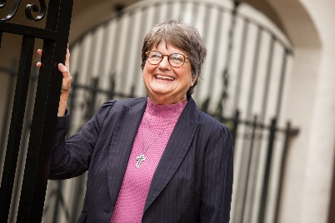
Sister Helen Prejean is known around the world for her tireless work against the death penalty. She has been instrumental in sparking national dialogue on capital punishment and in shaping the Catholic Church’s vigorous opposition to all executions. Born on April 21, 1939, in Baton Rouge, Louisiana, she joined the Sisters of St. Joseph in 1957. She worked as a high school teacher and served as the Religious Education Director at St. Frances Cabrini Parish in New Orleans before moving into the St. Thomas Housing Project in the early ’80s. In 1982, Sister Helen began corresponding with Patrick Sonnier, who had been sentenced to death for the murder of two teenagers. Two years later, when Patrick Sonnier was put to death in the electric chair, Sister Helen was there to witness his execution. In the following months, she became spiritual advisor to another death row inmate, Robert Lee Willie, who was to meet the same fate as Sonnier. After witnessing these executions, Sister Helen realized that this lethal ritual would remain unchallenged unless its secrecy was stripped away, and so she sat down and wrote a book, Dead Man Walking: An Eyewitness Account of the Death Penalty in the United States. That book ignited a national debate on capital punishment and spawned an Academy Award winning movie, a play, and an opera. Sister Helen’s second book, The Death of Innocents: An Eyewitness Account of Wrongful Executions, was published in 2004; and her third book, River of Fire: My Spiritual Journey, in August, 2019.

- Kirk Bloodsworth, Keynote Speaker – Executive Director of Witness to Innocence and subject of the book Bloodsworth: The True Story of the First Death Row Inmate Exonerated by DNA Evidence
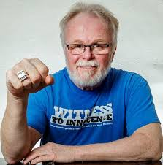
Kirk currently lives in Philadelphia and is the Executive Director of Witness to Innocence. Since his exoneration, Kirk has devoted himself to abolishing the death penalty and addressing wrongful convictions. He has testified before the United States Congress as well as numerous state legislatures. Kirk worked in eight of the nine states that have abolished the death penalty in the last 25 years, including his home state of Maryland, where his name was mentioned 64 times during the floor debate in the legislature. He was featured on Oprah twice as well as on CNN’s Larry King Live. He has authored op-eds and given countless other media interviews. Kirk has been an ardent supporter of the Innocence Protection Act, which is aimed at reducing the risk of executing innocent people. The Act established the Kirk Bloodsworth Post-Conviction DNA Testing Program to help states defray the costs of testing DNA evidence after conviction. Though the Act was signed into law in 2004, it took another four years of lobbying efforts to secure federal funding. Kirk fought to ensure that the program in his name was fully funded, and today it provides $10 million per year in federal grants. The mutual support and camaraderie of his fellow exonerees has been and continues to be of central importance to Kirk. He has been a member of Witness to Innocence since its inception. After teaching himself the art of silversmithing, Kirk created signature “exoneree” and “death row exoneree” 28g sterling silver rings, which he has gifted to 235 exonerees to date.

- Dan Satterberg, Keynote Speaker – King County Prosecuting Attorney
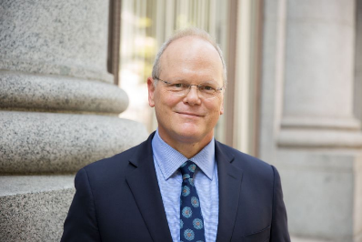
Dan Satterberg has served in the King County Prosecuting Attorney’s Office for more than three decades, and was first elected to lead the office in November 2007. He served as Chief of Staff to Norm Maleng for 17 years, and was responsible for the management and operation of the PAO. The KCPAO has 240 attorneys, and a total staff of more than 500. King County has more than 2.1 million residents, making it the 13th largest county in the United States. Dan is committed to improving public safety and the reform of the Criminal Justice system through partnership with the communities most impacted by crime. Together with community partners, Dan has created successful programs to keep young people engaged in school and divert youth from the courtroom to more effective and impactful accountability programs led by credible messengers to change the way young people think and act. The KCPAO is a founding partner in the creation of LEAD (Law Enforcement Assisted Diversion), a national model creating a compassionate response to drug-addicted people, and giving police additional tools for responding to people with addiction and mental health issues. Further work is being done to expand this concept in King County, and to identify and assist frequent utilizers of the jail before their next arrest. Dan also believes that we need to do more to help people leaving prison make a successful transition, and he is committed to reducing recidivism among people leaving jail and prison as the best strategy to improve public safety and reduce the costs of incarceration. He is the co-chair of the Washington State Reentry Council, and also a member of the Washington State Criminal Justice Training Commission. Dan was born and raised in South King County and attended Highline High School. His father was a lawyer in White Center and his mother was a nursing instructor at Highline Community College. He graduated from the UW undergraduate school (Political Science and Journalism) and the UW Law School. He has two adult children and has been married for more than 30 years. He also plays bass and sings in the classic rock cover band, “The Approximations.”

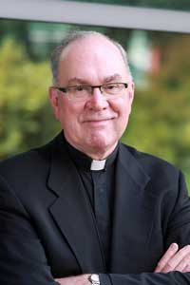
- Father Stephen Sundborg, President of Seattle University
Father Stephen V. Sundborg, of the Society of Jesus, is serving in his 23rd year as president of Seattle University. He leads a comprehensive, independent, Jesuit Catholic University of 7,400 undergraduate and graduate students and 1,600 faculty and staff members. In addition to his responsibilities as Seattle University president, Father Sundborg has served on the Boards of United Way of King County, YMCA of King County, the Lakeside School, the University of San Francisco and Georgetown University. He currently serves on the boards of Seattle Nativity School, the Fulcrum Foundation, and is the Chair of the Board of the Western Athletic Conference. Fr. Sundborg was recently chosen as the First Citizen of Seattle and King County for 2019. President Sundborg was ordained a priest in Seattle in 1974 and completed his doctoral studies in spirituality at the Pontifical Gregorian University in Rome in 1982. He taught theology at Seattle University from 1982-1990 and served as provincial of the Northwest Jesuits 1990-1996. A native of Alaska, Father Sundborg, whose father was an author of the Alaska State Constitution, is the 21st president to lead Seattle University since it was founded in 1891.

- Robert C. Boruchowitz, J.D., Professor of Practice & Director of The Defender Institute at Seattle University School of Law
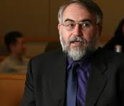
Dr. Boruchowitz directed Seattle’s Defender Association for 28 years. He founded the Defender’s Racial Disparity Project. He has appeared at every level of state and federal court. He has been an expert witness in systemic denial of counsel litigation and in excessive defender caseload cases. He was co-investigator on a study of the costs of seeking the death penalty. He was lead researcher and co-author of "Minor Crimes, Massive Waste--The Terrible Toll of America's Broken Misdemeanor Courts." He is working on a Justice Department funded project with the Sixth Amendment Center to improve public defense in several states. He developed a seminar and a clinic on Right to Counsel and taught in the Youth Advocacy Clinic and criminal procedure courses. He developed a seminar on Law and the Holocaust and the Abuse of Executive Power. He wrote a paper for the American Constitution Society on diverting and reclassifying misdemeanors. As founding president of Washington Defender Association and a founding member of the American Council of Chief Defenders, he has been instrumental in developing defender standards. He was a Soros Senior Fellow. He has received numerous awards including the NACDL Champion of Indigent Defense Award.

- Jacqueline McMurtrie, J.D. – Betts, Patterson, & Mines Professor of Law at University of Washington
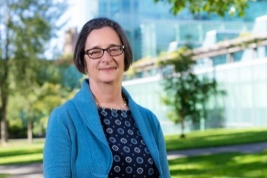
In 1997, she founded the Washington Innocence Project (formerly Innocence Project Northwest) - the nation's third innocence organization - and served as Director until 2015. As Director, Prof. McMurtrie led IPNW's growth from its roots as a volunteer effort to a law clinic and finally into a non-profit organization. To date, the Washington Innocence Project has exonerated 15 people who collectively served over 100 years in prison for crimes they did not commit and successfully advocated for Washington laws to compensate the wrongly convicted and to preserve biological evidence. Professor McMurtrie is a founding member of the Innocence Network, an affiliation of 67 organizations from all over the world. Professor McMurtrie's research and teaching interests revolve primarily around criminal law and appellate/post-conviction practice, with an emphasis on wrongful convictions. Her scholarship has been cited by United States Court of Appeals for the Seventh Circuit, eight of our States' highest courts, and several intermediary courts of appeal. Professor McMurtrie received her undergraduate and law degrees from the University of Michigan.

- Lara Zarowsky, J.D., Nonprofit Executive Director, Washington Innocence Project
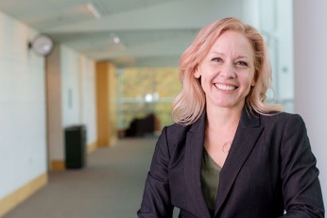
Lara Zarowsky joined the faculty in 2011 and established the Innocence Project Northwest track of the Legislative Advocacy Clinic. Her Clinic students championed the 2013 law to compensate Washington's wrongly convicted, and the 2015 law to preserve biological evidence. She has served as Director of the Legislative Advocacy Clinic since 2014. In addition to her clinical work, Professor Zarowsky teaches Negotiation and courses related to Legislation and Public Policy, with special emphasis on the Washington State legislative process. Professor Zarowsky began her law career in the Washington State Legislature where she served as non-partisan staff to the House Judiciary and Public Safety Committees. In addition to her teaching responsibilities, Professor Zarowsky serves as the Policy Director for Innocence Project Northwest where she leads the organization's efforts to collaborate with criminal justice leaders to improve statewide practices to prevent the conviction of the innocent. She lectures nationally on innocence-related criminal justice policy reform, and is a founding member of the working group whose efforts resulted in the 2015 adoption of science-based eyewitness identification standards by statewide law enforcement and prosecutor organizations.

- Dr. Heather D. Evans, Lecturer at University of Washington
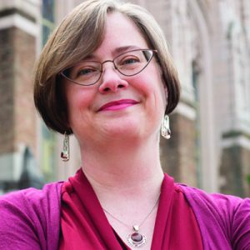
Dr. Heather D. Evans is a lecturer in the Department of Sociology; Disability Studies Program; and the Law, Societies & Justice Department at the University of Washington. She has conducted both statistical analyses and ethnographic fieldwork. Heather’s current work examines “invisible disability”, focusing on disclosure and identity management among people with physical, mental, and sensory differences that are not readily apparent. She is also committed to community-based research and does consulting work for local organizations, primarily focusing on disparities within the criminal justice system. Broadly, she is interested in processes of social marginalization and identifying ways to expand access to opportunity structures through institutional change.

- Dr. Peter Collins, Associate Professor in Criminal Justice at Seattle University
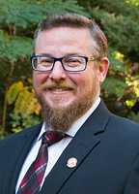
Dr. Collins earned his Ph.D. in criminal justice from Washington State University in 2011 with a focus on corrections, cost-benefit and evaluation research, and criminal justice organizations. His research interests include issues surrounding the death penalty, the intersection of criminal law and criminal justice policy, public policy analysis, and criminology within the context of popular culture. His work has been published in: The Journal of Criminal Justice, The Journal of Offender Rehabilitation, Criminal Justice Studies, The international Journal of Offender Therapy and Comparative Criminology, Western Criminology Review, Police Quarterly, The Prison Journal, Criminal Justice Policy Review, The Journal of Crime and Justice, The Seattle Journal for Social Justice, Routledge Press, Carolina Academic Press, LFB Scholarly Publishing, Oxford University Press, and Cognella Academic Publishing, among many other outlets. His current research focus remains on the intersection on public policy and the law, with particular emphasis on jury selection, economics and capital punishment, and victims of violent crime.

- Dr. Jacqueline Helfgott, Professor & Director of Seattle University’s Criminal Justice Crime and Research Center
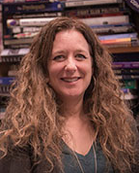
Dr. Helfgott has a PhD and MA in Administration of Justice from Pennsylvania State University and BA from the University of Washington in Psychology and Society & Justice. Her research interests include criminal behavior, psychopathy, copycat crime, corrections/reentry, policing and public safety, and crisis intervention in law enforcement. She is author of No Remorse: Psychopathy and Criminal Justice (Praeger, 2019), Criminal Behavior: Theories, Typologies, and Criminal Justice (Sage, 2008), Editor of Criminal Psychology, Volumes 1-4 (Praeger, 2013), coauthor of Offender Reentry: Beyond Crime and Punishment (Lynne Rienner Publishers, 2013) and Women Leading Justice: Experiences and Insights (Routledge, 2019). She is currently working on the book Copycat Crime: How Media, Technology, and Digital Culture Inspire Criminal Behavior and Violence (Praeger). Her work has been published in numerous peer-reviewed journals including: Aggression and Violent Behavior, Criminal Justice & Behavior, Forensic Psychology Practice, the Journal of Police and Criminal Psychology, the International Journal of Law and Psychiatry, the Journal of Prison Education and Reentry, Journal of Community Corrections, Federal Probation, Corrections Policy, Practice and Research, Women and Criminal Justice, the International Review of Victimology and the International Journal of Offender Therapy and Comparative Criminology. She has served as principal investigator on grant-funded research and service in policing, courts, corrections, and victim services. She is currently principal investigator on the Seattle Police Department’s Micro-Community Policing Plans, longitudinal evaluation of the Washington State Criminal Justice Training Commission’s Guardian-Oriented Law Enforcement Training, and Pilot Evaluation of the South King County Pretrial Services Pilot Program. She is a member of the American Society of Criminology, the Western Society of Criminology, the American Association of Threat Assessment Professionals, and the Society for the Scientific Study of Psychopathy.

- Dr. Matthew J. Hickman, Professor & Chair of the Department of Criminal Justice at Seattle University
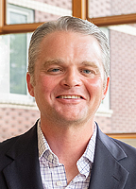
In addition to conducting research in the general areas of police integrity and ethics, forensic evidence processing, and quantitative research methods, he teaches a variety of both undergraduate- and graduate-level courses including statistics, research methods, criminology, forensic science, ethics, and crime mapping. Prior to joining the faculty at Seattle University in 2007, he was employed as a statistician at the Bureau of Justice Statistics (BJS), the statistical research arm of the U.S. Department of Justice, for seven years. There, he specialized in the development and analysis of national data collections relating to law enforcement operations as well as forensic crime laboratories and medicolegal death investigation systems in the United States. Hickman’s research has been published in numerous peer-reviewed journals including Criminology, Criminology & Public Policy, Journal of Quantitative Criminology, Sociological Methods and Research, Crime & Delinquency, Police Quarterly, and Policing. Books include Policing for the 21st Century: Realizing the Vision of Police in a Free Society (Kendall/Hunt, 2016), and edited volumes Forensic Science and the Administration of Justice (Sage, 2014) and Police Integrity and Ethics (Wadsworth/Thomson, 2004). He has written several book chapters for edited volumes including: Race, Ethnicity and Policing; Rational Choice and Criminal Behavior; and Encyclopedia of Police Science. Hickman is a past President of the Western Society of Criminology and he served as an Executive Counselor for the American Society of Criminology Division of Policing. He is a member of the American Society of Criminology, Western Society of Criminology, and the International Association of Crime Analysts.

- Dr. Katherine Beckett, Professor in the Department of Sociology and Law, Societies, & Justice
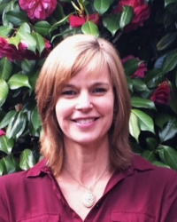
Katherine Beckett is a Professor in the Departments of Sociology and Law, Societies, and Justice. She is also a faculty affiliate of the West Coast Poverty Center and Clowes Center for the Study of Conflict and Dialogue, and a faculty associate and steering committee member of the Center for Human Rights at the University of Washington. Beckett received her Ph.D. in Sociology from the University of California at Los Angeles in 1994. Her research analyzes the causes and consequences of legal changes and penal practices. Beckett's early research analyzed how and why crime-related issues assumed a central place on the U.S. political agenda, and why enhanced punishment was embraced as the best solution to these problems. More recent research projects have explored the consequences of penal expansion for social inequality, the role of race in drug law enforcement, and the transformation of urban social control practices in the United States. She is the author of numerous articles and three books on these topics, including, most recently, Banished: The New Social Control in Urban America, published in 2010 by Oxford University Press and nominated for the C. Wright Mills Book Award.

- Michael Russo, J.D.
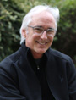
Michael Russo is a Distinguished Practitioner in Residence at Seattle University School of Law and teaches courses in Evidence, Criminal Law and Forensics. Before joining the faculty at S.U. Law in 2011, he was for 23 years a Deputy Public Defender in Los Angeles County, California. From 1995 to 2010, as a senior trial attorney, he was primarily focused on defending individuals charged in capital and non-capital murder cases. Professor Russo holds a B.A. degree from UCLA and a J.D. from UCLA School of Law. He is admitted to the Bar in California, Washington and the District of Columbia.

Strange Fruit: Poems on the Death Penalty - Reader Bios

- Ed Harkness is the author of three full-length poetry collections, Saying the Necessary, Beautiful Passing Lives, and most recently, The Law of the Unforeseen (2018, Pleasure Boat Studio press). His chapbook, Ice Children, was published by Split Lip Press in 2014. He lives in Shoreline, Washington.

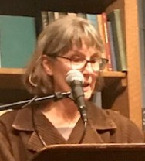
- Sally Hedges-Blanquez thanks her rural upbringing for being able to sew, garden, and read for hours. She later moved to Seattle where she taught for the Seattle Public Schools. She now shares plants, bouquets, and her words during Washington State’s stay-at-home order.

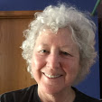
- Esther Altshul Helfgott is the author of Listening to Mozart: Poems of Alzheimer’s (Cave Moon Press, 2014); Dear Alzheimer’s: A Caregiver’s Diary & Poems (Cave Moon Press, 2013); The Homeless One: A Poem in Many Voices (Kota Press, 2000); and co-editor of So, Dear Writer… An It’s About Time Writers’ Reading Series Anthology (Cave Moon Press, 2019). Esther’s poems or essays have appeared in American Imago: Psychoanalysis and the Human Sciences; Beyond Forgetting: Poetry and Prose about Alzheimer’s Disease; BlackPast.org; HistoryLink.org; Journal of Poetry Therapy, Pontoon; Seattle P.I.; and elsewhere. She is a longtime literary activist, a 2010 Jack Straw poet, and founder of Seattle’s “It’s About Time Writer’s Reading Series,” now in its 30th year.

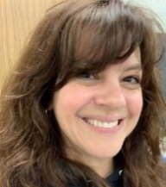
- Raechl Kynor is a poet, author, teacher, mom, and wife. She grew up in New Mexico and currently lives, writes, teaches, and loves in Southern California. With her BA in Literature and Creative Writing and her MEd degrees, she loves helping high school students discover the beauty and power of language through literature, poetry, and nonfiction. Her poems included in the anthology Strange Fruit are her first publications.

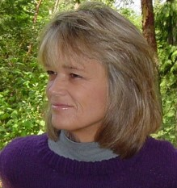
- Sarah Zale taught writing and poetry in Seattle, and presently teaches and works on Art for Justice Programs in Arizona. She believes in the power of poetry and the arts to transform and heal ourselves and the world. Sarah has published two collections. The Art of Folding: Poems (2010) was inspired by travels to Israel and Palestine. Her collection, Sometimes You Do Things: Poems (Aquarius Press, Living Detroit Series) highlights the history of Detroit and celebrates its rebuilding. Her publishing company, Wildflower Press, has released the anthology, Strange Fruit: Poems on the Death Penalty.

