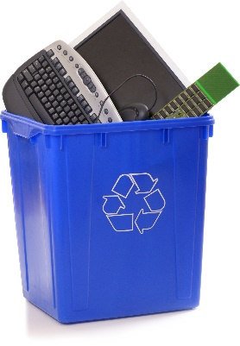
FREE ELECTRONICS RECYCLING

In addition to free recycling of your e-waste to reduce its impact on the environment, $1 for every 100 lbs of material that is collected from your event will be donated to EarthShare Washington supporting a range of very important causes:

  - Climate Change and Energy
  - Environmental Education
  - Forests, Parks and Land Conservation
  - Human Health/Children’s Health
  - Water Issues
  - Wildlife Protection

Find out more about EarthShare’s members and their mission at www.esw.org.

Items that will be accepted:
- TVs & Monitors - LCD and plasma
- Computers & Laptops
- Servers & Networking Equipment
- All printers, Fax Machines, and scanners
- Av Equipment (DVD/VHS/Stereo units)
- UPS battery backups
- Telecom Equipment & Cell Phones
- Keyboards and Mice
- Parts, peripherals, cables, etc.
- Microwaves too!

Sorry, we are unable to accept CRT TVs and monitors as well as alkaline batteries as part of this free collection event.

HOSTING LOCATION
TIME: 12:00–1:00
DATE: April 23rd, 2018

COLLECTION AREA
ADDRESS: 1111 E. Columbia
LOCATION INFO: Bellarmine turn-around

If you have any questions about this event please contact:

Contact Name: Steven West
Phone & Email: (206) 220-8480 westst@seattleu.edu
Or
206-582-7100 option 1
events@3rtechnology.com

